**du command:**

* du: disk usage
* du command is used to find the size of individual file or directory in Linux system.
* df command is used to determine file system disk space usage whereas du command is used to estimate/determine/find the size of file/directory.
* Command: du
* It will display the size of each file & directory within current (present) working directory.
* By default, figures (numbers) in output of du command is in kilobytes (KB).
* By default, du command displays file size of sub directories. It will not display individual file size of sub directories.
* To display individual file size of sub directories as well,

Command: du -a OR du --all

* To display size of files/directories in kilobytes (KB),

Command: du -k

* To display size of files/directories in megabytes (MB),

Command: du -m

* To display size of files/directories in human readable format,

Command: du -h

* To display total size of files/directories,

Command: du --total OR du -c

* To display summary of total files/directories size,

Command: du -s

* To exclude certain files and display remaining files/directories size,

Command: du --exclude=”*pattern*”

Example: du --exclude=”.txt”

It will not display files having txt extensions.

* To display disk usage based on modification of time,

Command: du --time

* Say, we have folder named ‘vbhv’ in current directory.

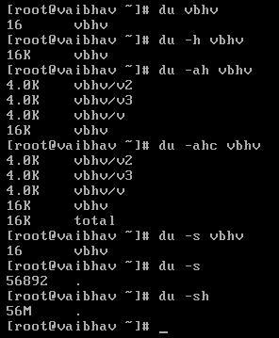

du -sh *